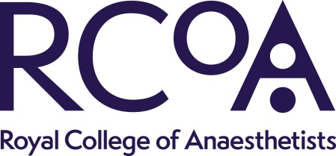
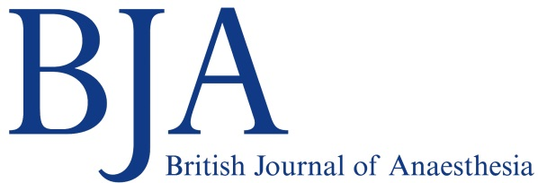
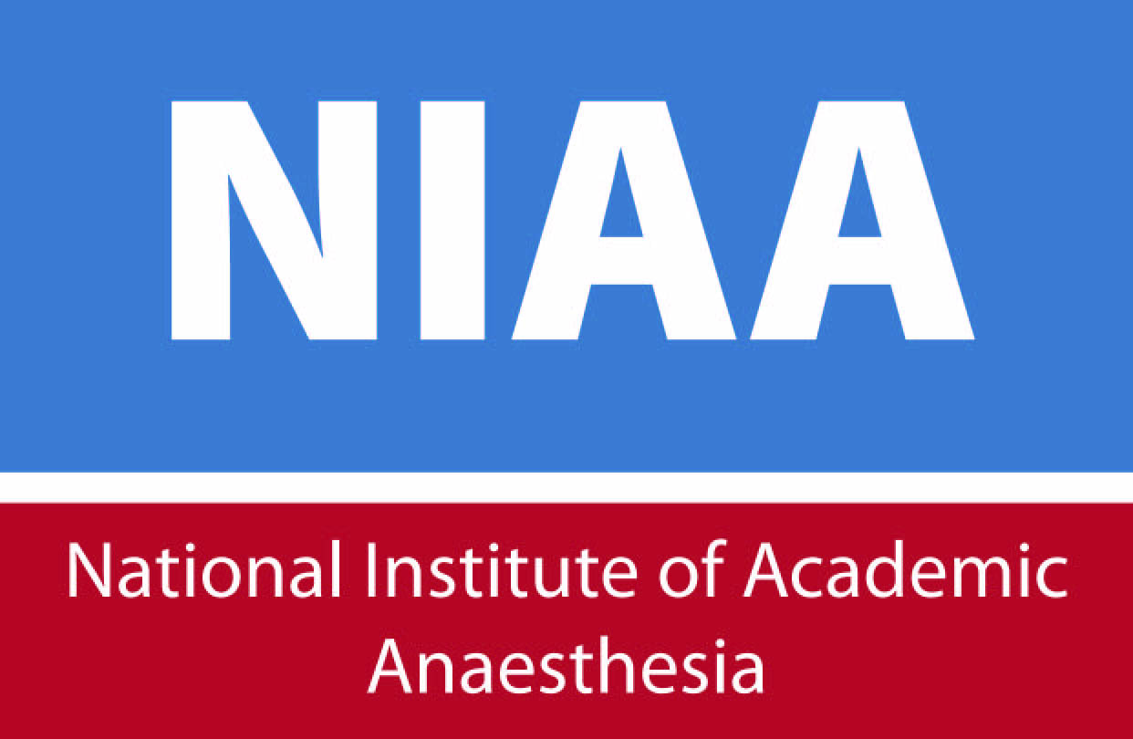

NATIONAL INSTITUTE OF ACADEMIC ANAESTHESIA
BJA/RCoA – Project Grant Application Form – 2019

Summary

Principal Applicant Title & Name:

Address :

Telephone:

Fax:

E-mail:

Principal Applicant gender: Male ☐
Female ☐
Prefer not to declare ☐

Names of any collaborators and Department(s) involved in the Project:

Please indicate how many hours per week EACH collaborator will give to this project:

Institution administering the grant:

Please indicate which project grant you are applying for:
☐ Up to £70,000
☐ Up to £100,000 (exceptional)
Title of Project:

Abstract of the proposed project (up to 200 words):

Lay Abstract (up to 500 words; this forms an integral part of the submission and should be written in language understandable by an educated non-medical reader). Please see guidance here: http://www.niaa.org.uk/article.php?newsid=637

Proposed starting date: Estimated duration:

Will this study use animals?
Yes ☐ No ☐

If so, which animal species?

If so, are any of the animals genetically modified?

Please list other grants currently held in this area of research:

If the proposed grant is in the same area as one of the above, how does the work differ from that currently funded?

Applicants who have previously been successfully funded by the BJA (within the past 3 years) should report the progress on their previous grant here:

BJA/RCoA Project Grant Application Form

- Details of the Grant requested (to be justified below in section B)

Salaries (all include NI and superannuation where appropriate)
Where appropriate agreed NHS research should be included

a. Research Staff
Grade:

Name:

Salary: Year 1

Year 2

Subtotal £

b. Technical Staff

Subtotal £

c. Apparatus

Subtotal £

d. Consumables and Other items

Subtotal £

TOTAL GRANT REQUESTED £

(Please include Superannuation, National Insurance and VAT where applicable).

NIHR Portfolio Adoption
Please note that unless you inform us that your study is suitable for NIHR portfolio adoption, applications for under £5,000 will be reviewed internally by the NIAA Grant Committee and will not be sent for external peer review.

If you intend to apply for portfolio support please could you confirm that here: Yes ☐
No ☐

BJA/RCoA Project Grant Application Form
Regulations

1. Applicant

“I understand and agree to comply with the conditions of the BJA/RCoA Project Grant. If successful, I will be involved directly in the proposed research project."

Name

Signature

Date

2. Head of Department

“I confirm that the details given in this application are correct. If successful, the grant will be administered in this department in accordance with the BJA/RCoA Project Grant conditions."

Name

Address

Telephone/Fax

Signature

Date

3. Institution Administrative Officer

“I confirm that the details given in this application, including the staff gradings and salaries are correct. Where appropriate, NHS research costs have been agreed and included in the costings. If successful, the grant will be administered by this institution in accordance with the BJA/RCoA Project Grant conditions. I accept that the BJA/RCoA will not contribute to any additional costs other than those specified in this form. I also agree that should any intellectual property rights or income accrue from this work, this will be shared between the BJA/RCoA and the host institution." (See next page for fuller information)

Name

Position

Address

Telephone/Fax

Signature

Date
The following important conditions attach to the award
- The institution administering the grant should invoice for the full amount of the award and this be done as a matter of urgency following notification of the award.
- Interim and end of project reports will be required as appropriate and you will be notified when to submit these. These may be posted on NIAA/BJA website.
- BJA funding should be acknowledged in all publications and copies forwarded to us (dgl3@le.ac.uk).
- BJA should be involved in any IP negotiations resulting from this work (see below).
- The BJA does not fund University overheads (including FEC).
- Costings should include appropriate increments to salaries. Inflation should be included where appropriate at 2.5%
- Where appropriate agreed NHS research should be included.

Intellectual Property

“The British Journal of Anaesthesia is obliged to ensure that useful results from the research that it funds (whether whole or in part) are applied for the public good. In some circumstances, this may be best achieved by the protection of intellectual property and commercial exploitation.

The British Journal of Anaesthesia therefore requires all Award Holders, funded personnel and Institutions to consider whether the protection, management and exploitation of British Journal of Anaesthesia funded Intellectual Property is an appropriate means of achieving public benefit, and to develop and implement strategies and procedures for the identification, protection, management and exploitation of the British Journal of Anaesthesia Intellectual Property.

The British Journal of Anaesthesia is also obliged to ensure that it obtains a fair share of any fruits of its funded research. The British Journal of Anaesthesia requires Award Holders and Institutions to notify the British Journal of Anaesthesia promptly in writing when Intellectual Property that may be of medical or commercial value arises from the Award, and to ensure that such Intellectual Property is not published nor inappropriately disclosed prior to protection. Intellectual Property arising from the Award may not be exploited or disposed of in any way without the prior written approval of the British Journal of Anaesthesia, such consent not to be reasonably withheld. As a condition of such consent the British Journal of Anaesthesia will require the Institution to enter into dialogue regarding the mutually acceptable exploitation or disposal of the Intellectual Property in question. British Journal of Anaesthesia reserves the right to seek redress.”
A
A full and detailed description of the research project in 2,500 to 3,500 words (plus references)
Title:
Aims:
Background:
Experimental design and methods:
Statistical considerations:
Expected outcomes:
Pathways to impact:
Outline of study flow / CONSORT chart (or other as appropriate):
References:
B
A detailed justification of the BJA/RCoA Project Grant support requested. N.B. This includes your consumable items. Reviewers often question this section of the application.
C
Details of Patient & Public Involvement in the research. Any public involvement carried out so far or planned during the research project should be outlined. If no public involvement is planned or necessary, for example in laboratory studies, please explain why this is not required.
You can get support for Patient and Public Involvement in your research by contacting your hospital’s patient group, your local NIHR Research and Design Service, your local NIHR Clinical Research Network public involvement co-ordinator, patient groups and charities or the NIAA-HSRC’s PCPIE Group but we would recommend doing this as soon as possible to incorporate their advice before submitting your application.
D
A list of any resources, including financial that the host institutions for the project will provide
E
Details of any support requested for the project from any other sources, excluding grant awarding bodies (Please see note on dual submission)
F
Evidence of Ethics Committee approval or a Project Licence for animal experimentation. This is not necessary for submission, but will be required before any grant is awarded to a successful applicant.
G
Principal Applicant CV

Submission

Closing date: Noon, Friday 20 September 2019

All applications and requested supporting paperwork must be uploaded as a single pdf document to: http://mc.manuscriptcentral.com/niaa-grants
Applications should be uploaded as a single pdf file. Abstract and lay summary information should be copied and pasted from this file into the text boxes provided on the system.

The NIAA administers the grant awarding process on behalf of its partner organisations. Grant applications and the personal data of applicants will be shared with those organisations on the basis of legitimate interests for processing the funding linked to an award and fulfilling ongoing reporting requirements.

Guidance and FAQs are available on the NIAA website here: http://niaa.org.uk/NIAA-Research-Grants-Application-guidance#pt

Email any queries to: info@niaa.org.uk

Please be advised that incomplete, unsigned or late applications will not be considered. It is the applicant’s responsibility to ensure that the full application is successfully uploaded before the closing date. You will receive an automated acknowledgment email once your application has been received by us. Note that there is no longer any requirement to submit a hard copy of your application.

Reporting on NIAA Grants
Should this application be successful, please be aware that it is now a condition for any NIAA facilitated grant-holder to submit annual reports on the outcomes of their awarded grant through the Researchfish Impact Assessment platform: https://www.researchfish.net/

Information on the requirements necessary to fulfil this obligation will be sent with your grant notification, once a decision has been made on your application.

