 



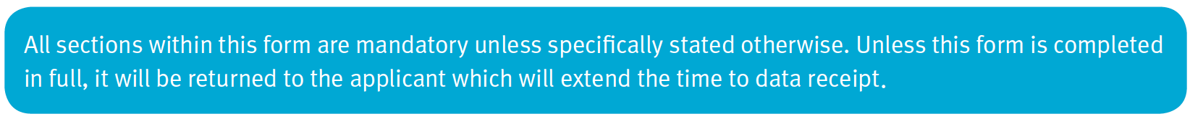

|  |  |  |  |
| --- | --- | --- | --- |
| *../Images/Screenshots/Screen%20Shot%202017-03-07%20at%2016.17.49.png* | | | |
| ../Images/Screenshots/Screen%20Shot%202017-03-07%20at%2016.17.57.png | Click or tap here to enter text. | ../Images/Screenshots/Screen%20Shot%202017-03-07%20at%2016.18.10.png | Click or tap here to enter text. |
| ../Images/Screenshots/Screen%20Shot%202017-03-07%20at%2016.18.02.png | Click or tap here to enter text. | | |

|  |  |  |  |  |  |  |
| --- | --- | --- | --- | --- | --- | --- |
| **../Images/Screenshots/Section%201.png** |  | | | | | |
| ../Images/Screenshots/Screen%20Shot%202017-03-07%20at%2016.18.18.png | Click or tap here to enter text. | | | | | |
| ../Images/Screenshots/Screen%20Shot%202017-03-07%20at%2016.18.24.png | Click or tap here to enter text. | | | | | |
| ../Images/Screenshots/Screen%20Shot%202017-03-07%20at%2016.18.31.png | Click or tap here to enter text. | | | | | |
| ../Images/Screenshots/Screen%20Shot%202017-03-07%20at%2016.18.39.png | Click or tap here to enter text. | | ../Images/Screenshots/Screen%20Shot%202017-03-07%20at%2016.18.44.png | | Click or tap here to enter text. | |
| ../Images/Screenshots/Screen%20Shot%202017-03-07%20at%2016.18.52.png | Click or tap here to enter text. | | ../Images/Screenshots/Screen%20Shot%202017-03-07%20at%2016.19.02.png | | Click or tap here to enter text. | |
| ../Images/Screenshots/Screen%20Shot%202017-03-07%20at%2016.19.08.png../Images/Screenshots/Please%20select%20one%20answer.png../Images/Screenshots/Please%20select%20one%20answer.png | ../Images/Screenshots/Screen%20Shot%202017-03-07%20at%2016.19.14.png | ../Images/Screenshots/Screen%20Shot%202017-03-07%20at%2016.19.20.png | | ../Images/Screenshots/Screen%20Shot%202017-03-07%20at%2016.19.27.png | | ../Images/Screenshots/Screen%20Shot%202017-03-07%20at%2016.19.34.png |
|  |  | |  | |  |
| ../Images/Screenshots/Screen%20Shot%202017-03-07%20at%2016.19.43.png | ../Images/Screenshots/Screen%20Shot%202017-03-07%20at%2016.19.49.png | | ../Images/Screenshots/Screen%20Shot%202017-03-07%20at%2016.19.54.png | | ../Images/Screenshots/Screen%20Shot%202017-03-07%20at%2016.19.59.png |
|  |  | |  | |  |
| ../Images/Screenshots/Screen%20Shot%202017-03-07%20at%2016.20.07.png | ../Images/Screenshots/Screen%20Shot%202017-03-07%20at%2016.20.52.png | | | | | |
| Click or tap here to enter text. | | | | | |

|  |  |  |  |
| --- | --- | --- | --- |
| **../Images/Screenshots/Section%202.png** | **../Images/Screenshots/Application%20Type.png** | | |
| *../Images/Screenshots/Screen%20Shot%202017-03-07%20at%2016.21.37.png* | | | |
| ../Images/Screenshots/Screen%20Shot%202017-03-07%20at%2016.21.52.png | | ../Images/Screenshots/Screen%20Shot%202017-03-07%20at%2016.21.58.png | ../Images/Screenshots/Screen%20Shot%202017-03-07%20at%2016.22.04.png |
| ../Images/Screenshots/Screen%20Shot%202017-03-07%20at%2016.23.16.png | | ../Images/Screenshots/Screen%20Shot%202017-03-07%20at%2016.23.25.png | ../Images/Screenshots/Screen%20Shot%202017-03-07%20at%2016.23.25.png |
| ../Images/Screenshots/Screen%20Shot%202017-03-07%20at%2016.23.43.png | |  |  |
| ../Images/Screenshots/Screen%20Shot%202017-03-07%20at%2016.23.57.png | |  |  |
| ../Images/Screenshots/Screen%20Shot%202017-03-07%20at%2016.24.11.png | |  |  |
| ../Images/Screenshots/Screen%20Shot%202017-03-07%20at%2016.24.20.png | | | |
| Click or tap here to enter text. | | | |

|  |  |  |  |  |
| --- | --- | --- | --- | --- |
| **../Images/Screenshots/Screen%20Shot%202017-03-07%20at%2016.27.01.png** | **../Images/Screenshots/Screen%20Shot%202017-03-07%20at%2016.27.07.png** | | | |
| ../Images/Screenshots/Screen%20Shot%202017-03-07%20at%2016.27.34.png../Images/Screenshots/Please%20select%20one%20answer.png | ../Images/Screenshots/Screen%20Shot%202017-03-07%20at%2016.27.13.png | ../Images/Screenshots/Screen%20Shot%202017-03-07%20at%2016.27.17.png | ../Images/Screenshots/Screen%20Shot%202017-03-07%20at%2016.27.23.png | ../Images/Screenshots/Screen%20Shot%202017-03-07%20at%2016.27.28.png |
|  |  |  |  |
|  | | | |
| Click or tap here to enter text. | | | |

|  |  |
| --- | --- |
| **../Images/Screenshots/Screen%20Shot%202017-03-07%20at%2016.28.00.png** | **../Images/Screenshots/Screen%20Shot%202017-03-07%20at%2016.28.06.png** |
| *../Images/Screenshots/Screen%20Shot%202017-03-07%20at%2016.28.14.png* | |
| ../Images/Screenshots/Screen%20Shot%202017-03-07%20at%2016.28.24.png | Click or tap here to enter text. |
| ../Images/Screenshots/Screen%20Shot%202017-03-07%20at%2016.28.31.png | Click or tap here to enter text. |
| ../Images/Screenshots/Screen%20Shot%202017-03-07%20at%2016.28.35.png | Click or tap here to enter text. |

|  |  |  |  |  |
| --- | --- | --- | --- | --- |
| **../Images/Screenshots/Screen%20Shot%202017-03-07%20at%2016.28.41.png** | | **../Images/Screenshots/Screen%20Shot%202017-03-07%20at%2016.28.47.png** | | |
|  | | | *../Images/Screenshots/Screen%20Shot%202017-03-07%20at%2016.30.28.png* | |
| ../Images/Screenshots/Screen%20Shot%202017-03-07%20at%2016.33.16.png | | |  | **../Images/Screenshots/Screen%20Shot%202017-03-07%20at%2016.33.30.png** |
| ../Images/Screenshots/Screen%20Shot%202017-03-07%20at%2016.34.40.png | Click or tap here to enter text. | | Click or tap here to enter text. | ../Images/Screenshots/Screen%20Shot%202017-03-07%20at%2016.33.42.png |
| ../Images/Screenshots/Screen%20Shot%202017-03-07%20at%2016.34.45.png | Click or tap here to enter text. | | Click or tap here to enter text. | ../Images/Screenshots/Screen%20Shot%202017-03-07%20at%2016.33.42.png |
| ../Images/Screenshots/Screen%20Shot%202017-03-07%20at%2016.34.49.png | Click or tap here to enter text. | | Click or tap here to enter text. | ../Images/Screenshots/Screen%20Shot%202017-03-07%20at%2016.33.42.png |
| ../Images/Screenshots/Screen%20Shot%202017-03-07%20at%2016.34.54.png | Click or tap here to enter text. | | Click or tap here to enter text. | ../Images/Screenshots/Screen%20Shot%202017-03-07%20at%2016.33.42.png |

|  |  |  |  |  |
| --- | --- | --- | --- | --- |
| **../Images/Screenshots/Screen%20Shot%202017-03-07%20at%2016.35.20.png** | **../Images/Screenshots/Screen%20Shot%202017-03-07%20at%2016.35.26.png** | | | |
| *../Images/Screenshots/Screen%20Shot%202017-03-07%20at%2016.35.40.png* | | | | |
| ../Images/Screenshots/Screen%20Shot%202017-03-07%20at%2016.35.55.png |  | ../Images/Screenshots/Screen%20Shot%202017-03-07%20at%2016.35.47.png |  | ../Images/Screenshots/Screen%20Shot%202017-03-07%20at%2016.36.07.png |
| Click or tap here to enter text. | | | |
| ../Images/Screenshots/Screen%20Shot%202017-03-07%20at%2016.36.12.png |  | ../Images/Screenshots/Screen%20Shot%202017-03-07%20at%2016.35.47.png |  | ../Images/Screenshots/Screen%20Shot%202017-03-07%20at%2016.36.19.png |
| Click or tap here to enter text. | | | |

|  |  |  |  |  |
| --- | --- | --- | --- | --- |
| **../Images/Screenshots/Screen%20Shot%202017-03-07%20at%2016.36.28.png** | **../Images/Screenshots/Screen%20Shot%202017-03-07%20at%2016.36.34.png** | | | |
| *../Images/Screenshots/Screen%20Shot%202017-03-07%20at%2016.36.39.png* | | | | |
| ../Images/Screenshots/Screen%20Shot%202017-03-07%20at%2016.36.49.png |  | ../Images/Screenshots/Screen%20Shot%202017-03-07%20at%2016.35.47.png |  | ../Images/Screenshots/Screen%20Shot%202017-03-07%20at%2016.37.02.png |
| Click or tap here to enter text. | | | |

|  |  |  |  |  |
| --- | --- | --- | --- | --- |
| **../Images/Screenshots/Screen%20Shot%202017-03-07%20at%2016.37.09.png** | **../Images/Screenshots/Screen%20Shot%202017-03-07%20at%2016.37.20.png** | | | |
| **../Images/Screenshots/Screen%20Shot%202017-03-07%20at%2016.37.37.png../Images/Screenshots/Please%20select%20one%20answer.png** | *../Images/Screenshots/Screen%20Shot%202017-03-07%20at%2016.37.28.png* | | | |
| ../Images/Screenshots/Screen%20Shot%202017-03-07%20at%2016.37.42.png | ../Images/Screenshots/Screen%20Shot%202017-03-07%20at%2016.37.54.png | | ../Images/Screenshots/Screen%20Shot%202017-03-07%20at%2016.38.04.png |
| ../Images/Screenshots/Screen%20Shot%202017-03-07%20at%2016.37.49.png | ../Images/Screenshots/Screen%20Shot%202017-03-07%20at%2016.37.59.png | | ../Images/Screenshots/Screen%20Shot%202017-03-07%20at%2016.38.09.png |
| Click or tap here to enter text. | | | |
| **../Images/Screenshots/Screen%20Shot%202017-03-07%20at%2016.38.23.png** | *../Images/Screenshots/Screen%20Shot%202017-03-07%20at%2016.38.28.png* | | | |
| Click or tap here to enter text. | | | |
| **../Images/Screenshots/Screen%20Shot%202017-03-07%20at%2016.38.37.png** | *../Images/Screenshots/Screen%20Shot%202017-03-07%20at%2016.38.43.png* | | | |
| Click or tap here to enter text. | | | |
| **../Images/Screenshots/Screen%20Shot%202017-03-07%20at%2016.39.33.png ../Images/Screenshots/Please%20select%20one%20answer.png** | ../Images/Screenshots/Screen%20Shot%202017-03-07%20at%2016.39.39.png | | | |
| ../Images/Screenshots/Screen%20Shot%202017-03-07%20at%2016.39.49.png | | ../Images/Screenshots/Screen%20Shot%202017-03-07%20at%2016.40.05.png | |
| ../Images/Screenshots/Screen%20Shot%202017-03-07%20at%2016.39.55.png | | ../Images/Screenshots/Screen%20Shot%202017-03-07%20at%2016.40.10.png | |
| ../Images/Screenshots/Screen%20Shot%202017-03-07%20at%2016.40.00.png | | Click or tap here to enter text. | |

|  |  |  |
| --- | --- | --- |
| **../Images/Screenshots/Screen%20Shot%202017-03-07%20at%2016.40.32.png** | **../Images/Screenshots/Screen%20Shot%202017-03-07%20at%2016.40.38.png** | |
| *../Images/Screenshots/Screen%20Shot%202017-03-07%20at%2016.41.16.png* | | |
| ../Images/Screenshots/Screen%20Shot%202017-03-07%20at%2016.41.27.png | |  |
| *../Images/Screenshots/Screen%20Shot%202017-03-07%20at%2016.41.36.png* | |  |
| ../Images/Screenshots/Screen%20Shot%202017-03-07%20at%2016.41.46.png | |  |

|  |  |  |  |
| --- | --- | --- | --- |
| **../Images/Screenshots/Screen%20Shot%202017-03-07%20at%2016.42.27.png** | **../Images/Screenshots/Screen%20Shot%202017-03-07%20at%2016.42.34.png** | | |
|  | | | |
| **../Images/Screenshots/Screen%20Shot%202017-03-07%20at%2016.42.50.png** | *../Images/Screenshots/Screen%20Shot%202017-03-07%20at%2016.43.00.png* | *../Images/Screenshots/Screen%20Shot%202017-03-07%20at%2016.43.06.png* | *../Images/Screenshots/Screen%20Shot%202017-03-07%20at%2016.43.14.png* |
| *../Images/Screenshots/Screen%20Shot%202017-03-07%20at%2016.43.21.png* | *../Images/Screenshots/Screen%20Shot%202017-03-07%20at%2016.43.28.png* | *../Images/Screenshots/Screen%20Shot%202017-03-07%20at%2016.43.32.png* | *../Images/Screenshots/Screen%20Shot%202017-03-07%20at%2016.43.37.png* |
| Click or tap here to enter text. | Click or tap here to enter text. | Click or tap here to enter text. | Click or tap here to enter text. |
| Click or tap here to enter text. | Click or tap here to enter text. | Click or tap here to enter text. | Click or tap here to enter text. |
| Click or tap here to enter text. | Click or tap here to enter text. | Click or tap here to enter text. | Click or tap here to enter text. |
| Click or tap here to enter text. | Click or tap here to enter text. | Click or tap here to enter text. | Click or tap here to enter text. |
| Click or tap here to enter text. | Click or tap here to enter text. | Click or tap here to enter text. | Click or tap here to enter text. |
| Click or tap here to enter text. | Click or tap here to enter text. | Click or tap here to enter text. | Click or tap here to enter text. |
| Click or tap here to enter text. | Click or tap here to enter text. | Click or tap here to enter text. | Click or tap here to enter text. |
| Click or tap here to enter text. | Click or tap here to enter text. | Click or tap here to enter text. | Click or tap here to enter text. |
| Click or tap here to enter text. | Click or tap here to enter text. | Click or tap here to enter text. | Click or tap here to enter text. |
| Click or tap here to enter text. | Click or tap here to enter text. | Click or tap here to enter text. | Click or tap here to enter text. |
| Click or tap here to enter text. | Click or tap here to enter text. | Click or tap here to enter text. | Click or tap here to enter text. |
| Click or tap here to enter text. | Click or tap here to enter text. | Click or tap here to enter text. | Click or tap here to enter text. |
| Click or tap here to enter text. | Click or tap here to enter text. | Click or tap here to enter text. | Click or tap here to enter text. |

|  |  |
| --- | --- |
| **../Images/Screenshots/Screen%20Shot%202017-03-07%20at%2016.43.45.png** | **../Images/Screenshots/Screen%20Shot%202017-03-07%20at%2016.43.51.png** |
| ../Images/Screenshots/Screen%20Shot%202017-03-07%20at%2016.44.42.png | |
| Click or tap here to enter text. | |

|  |  |  |  |  |
| --- | --- | --- | --- | --- |
| **../Images/Screenshots/Screen%20Shot%202017-03-07%20at%2016.45.29.png** | **../Images/Screenshots/Screen%20Shot%202017-03-07%20at%2016.45.36.png** | | | |
| ../Images/Screenshots/Screen%20Shot%202017-03-07%20at%2016.45.48.png | | | | |
| **../Images/Screenshots/Screen%20Shot%202017-03-07%20at%2016.46.01.png** | **../Images/Screenshots/Screen%20Shot%202017-03-07%20at%2016.46.07.png** | **../Images/Screenshots/Screen%20Shot%202017-03-07%20at%2016.46.12.png** | **../Images/Screenshots/Screen%20Shot%202017-03-07%20at%2016.46.19.png** | |
| **../Images/Screenshots/Screen%20Shot%202017-03-07%20at%2016.46.28.png** | Click or tap here to enter text. | Click or tap here to enter text. |  | ../Images/Screenshots/Screen%20Shot%202017-03-07%20at%2016.46.36.png |
| **../Images/Screenshots/Screen%20Shot%202017-03-07%20at%2016.46.41.png** | Click or tap here to enter text. | Click or tap here to enter text. |  | ../Images/Screenshots/Screen%20Shot%202017-03-07%20at%2016.46.36.png |
| **../Images/Screenshots/Screen%20Shot%202017-03-07%20at%2016.46.51.png** | Click or tap here to enter text. | Click or tap here to enter text. |  | ../Images/Screenshots/Screen%20Shot%202017-03-07%20at%2016.46.36.png |
| **../Images/Screenshots/Screen%20Shot%202017-03-07%20at%2016.46.56.png** | Click or tap here to enter text. | Click or tap here to enter text. |  | ../Images/Screenshots/Screen%20Shot%202017-03-07%20at%2016.46.36.png |
| **../Images/Screenshots/Screen%20Shot%202017-03-07%20at%2016.47.02.png** | Click or tap here to enter text. | Click or tap here to enter text. |  | ../Images/Screenshots/Screen%20Shot%202017-03-07%20at%2016.46.36.png |
| **../Images/Screenshots/Screen%20Shot%202017-03-07%20at%2016.47.07.png** | Click or tap here to enter text. | Click or tap here to enter text. |  | ../Images/Screenshots/Screen%20Shot%202017-03-07%20at%2016.46.36.png |
| **../Images/Screenshots/Screen%20Shot%202017-03-07%20at%2016.47.15.png** | Click or tap here to enter text. | | | |



|  |  |  |  |  |
| --- | --- | --- | --- | --- |
| **../Images/Screenshots/Screen%20Shot%202017-03-07%20at%2016.47.44.png** | **../Images/Screenshots/Screen%20Shot%202017-03-07%20at%2016.47.50.png** | | | |
| ../Images/Screenshots/Screen%20Shot%202017-03-07%20at%2016.47.57.png | | | | |
| ../Images/Screenshots/Screen%20Shot%202017-03-07%20at%2016.48.05.png | Click or tap here to enter text. | | | |
| **../Images/Screenshots/Screen%20Shot%202017-03-07%20at%2016.48.13.png** | Click or tap here to enter text. | | | |
| **../Images/Screenshots/Screen%20Shot%202017-03-07%20at%2016.48.19.png** | Click or tap here to enter text. | | | |
| **../Images/Screenshots/Screen%20Shot%202017-03-07%20at%2016.48.25.png** | Click or tap here to enter text. | | | |
| ../Images/Screenshots/Screen%20Shot%202017-03-07%20at%2016.48.33.png |  | ../Images/Screenshots/Screen%20Shot%202017-03-07%20at%2016.48.43.png |  | ../Images/Screenshots/Screen%20Shot%202017-03-07%20at%2016.48.47.png ../Images/Screenshots/Screen%20Shot%202017-03-07%20at%2016.48.51.png |
| Click or tap here to enter text. | | | |

|  |  |  |  |  |  |  |
| --- | --- | --- | --- | --- | --- | --- |
| **../Images/Screenshots/Screen%20Shot%202017-03-07%20at%2016.54.25.png** | **../Images/Screenshots/Screen%20Shot%202017-03-07%20at%2016.54.30.png** | | | | | |
| ../Images/Screenshots/Screen%20Shot%202017-03-07%20at%2016.54.36.png | | | | | | |
| **../Images/Screenshots/Screen%20Shot%202017-03-07%20at%2016.54.44.png** |  | ../Images/Screenshots/Screen%20Shot%202017-03-07%20at%2016.55.04.png | | | | |
|  | ../Images/Screenshots/Screen%20Shot%202017-03-07%20at%2016.55.15.png | | | | |
| ../Images/Screenshots/Screen%20Shot%202017-03-07%20at%2016.55.21.png | | | | | |
|  | ../Images/Screenshots/Screen%20Shot%202017-03-07%20at%2016.55.27.png |  | ../Images/Screenshots/Screen%20Shot%202017-03-07%20at%2016.55.36.png |  | ../Images/Screenshots/Screen%20Shot%202017-03-07%20at%2016.56.52.png |
|  | ../Images/Screenshots/Screen%20Shot%202017-03-07%20at%2016.56.58.png | | | | |
| Click or tap here to enter text. | | | | | |

|  |  |
| --- | --- |
| **../Images/Screenshots/Screen%20Shot%202017-03-07%20at%2016.57.06.png** |  |
| ../Images/Screenshots/Screen%20Shot%202017-03-07%20at%2016.57.18.png | |
| Click or tap here to enter text. | |

|  |  |  |  |  |
| --- | --- | --- | --- | --- |
| **../Images/Screenshots/Screen%20Shot%202017-03-07%20at%2016.57.27.png** | **../Images/Screenshots/Screen%20Shot%202017-03-07%20at%2016.57.34.png** | | | |
| ../Images/Screenshots/Screen%20Shot%202017-03-07%20at%2016.57.44.png | | | | |
| ../Images/Screenshots/Screen%20Shot%202017-03-07%20at%2016.57.54.png |  | ../Images/Screenshots/Screen%20Shot%202017-03-07%20at%2016.58.05.png |  | ../Images/Screenshots/Screen%20Shot%202017-03-07%20at%2016.58.10.png |
| Click or tap here to enter text. | | | |

|  |  |  |  |
| --- | --- | --- | --- |
| **../Images/Screenshots/Screen%20Shot%202017-03-07%20at%2016.58.41.png** | **../Images/Screenshots/Screen%20Shot%202017-03-07%20at%2016.59.14.png** | | |
| ../Images/Screenshots/Screen%20Shot%202017-03-07%20at%2016.59.21.png | | Click or tap here to enter text. | |
| ../Images/Screenshots/Screen%20Shot%202017-03-07%20at%2016.59.28.png | | Click or tap here to enter text. | |
| ../Images/Screenshots/Screen%20Shot%202017-03-07%20at%2016.59.34.png | | Click or tap here to enter text. | |
| ../Images/Screenshots/Screen%20Shot%202017-03-07%20at%2016.59.42.png | |  | ../Images/Screenshots/Screen%20Shot%202017-03-07%20at%2016.59.49.png |

|  |  |  |  |  |
| --- | --- | --- | --- | --- |
| **../Images/Screenshots/Screen%20Shot%202017-03-07%20at%2016.59.55.png** | | **../Images/Screenshots/Screen%20Shot%202017-03-07%20at%2017.00.01.png** | | |
| ../Images/Screenshots/Screen%20Shot%202017-03-07%20at%2017.00.06.png | | | | |
|  | ../Images/Screenshots/Screen%20Shot%202017-03-07%20at%2017.00.11.png | |  | ../Images/Screenshots/Screen%20Shot%202017-03-07%20at%2017.00.16.png |
| Click or tap here to enter text. | | | | |

|  |  |  |
| --- | --- | --- |
| **../Images/Screenshots/Screen%20Shot%202017-03-07%20at%2017.00.24.png** | | **../Images/Screenshots/Screen%20Shot%202017-03-07%20at%2017.00.29.png** |
| ../Images/Screenshots/Screen%20Shot%202017-03-07%20at%2017.00.34.png | | |
|  | ../Images/Screenshots/Screen%20Shot%202017-03-07%20at%2017.00.41.png | |

|  |  |
| --- | --- |
| **../Images/Screenshots/Screen%20Shot%202017-03-07%20at%2017.00.45.png** | **../Images/Screenshots/Screen%20Shot%202017-03-07%20at%2017.00.50.png** |
| ../Images/Screenshots/Screen%20Shot%202017-03-07%20at%2017.00.55.png | |
| Click or tap here to enter text. | |

|  |  |  |
| --- | --- | --- |
| **../Images/Screenshots/Screen%20Shot%202017-03-07%20at%2017.01.04.png** | | **../Images/Screenshots/Screen%20Shot%202017-03-07%20at%2017.01.10.png** |
| ../Images/Screenshots/Screen%20Shot%202017-03-07%20at%2017.01.15.png | | |
|  | ../Images/Screenshots/Screen%20Shot%202017-03-07%20at%2017.01.20.png | |

|  |  |  |  |  |  |  |  |  |  |
| --- | --- | --- | --- | --- | --- | --- | --- | --- | --- |
| **../Images/Screenshots/Screen%20Shot%202017-03-07%20at%2017.03.00.png** | | **../Images/Screenshots/Screen%20Shot%202017-03-07%20at%2017.03.06.png** | | | | | | | |
| ../Images/Screenshots/Screen%20Shot%202017-03-07%20at%2017.03.11.png | | | | | | | | | |
| **../Images/Screenshots/Screen%20Shot%202017-03-07%20at%2017.03.22.png** | **../Images/Screenshots/Screen%20Shot%202017-03-07%20at%2017.03.27.png** | | | | | | **../Images/Screenshots/Screen%20Shot%202017-03-07%20at%2017.03.33.png** | | |
| **../Images/Screenshots/Screen%20Shot%202017-03-07%20at%2017.03.39.png** | ../Images/Screenshots/Screen%20Shot%202017-03-07%20at%2017.03.44.png | | ../Images/Screenshots/Screen%20Shot%202017-03-07%20at%2017.03.48.png | ../Images/Screenshots/Screen%20Shot%202017-03-07%20at%2017.03.54.png | ../Images/Screenshots/Screen%20Shot%202017-03-07%20at%2017.04.19.png | ../Images/Screenshots/Screen%20Shot%202017-03-07%20at%2017.04.24.png  <https://ico.org.uk/media/1061/anonymisation-code.pdf> | <https://ico.org.uk/media/for-organisations/documents/1068/data_sharing_code_of_practice.pdf> |  | ../Images/Screenshots/Screen%20Shot%202017-03-07%20at%2017.04.42.png |
| **../Images/Screenshots/Screen%20Shot%202017-03-07%20at%2017.04.48.png** | ../Images/Screenshots/Screen%20Shot%202017-03-07%20at%2017.04.52.png | |  | ../Images/Screenshots/Screen%20Shot%202017-03-07%20at%2017.04.52.png | ../Images/Screenshots/Screen%20Shot%202017-03-07%20at%2017.04.52.png |  | ../Images/Screenshots/Screen%20Shot%202017-03-07%20at%2017.04.52.png |  |  |
| **../Images/Screenshots/Screen%20Shot%202017-03-07%20at%2017.05.43.png** | ../Images/Screenshots/Screen%20Shot%202017-03-07%20at%2017.04.52.png | | ../Images/Screenshots/Screen%20Shot%202017-03-07%20at%2017.04.52.png | ../Images/Screenshots/Screen%20Shot%202017-03-07%20at%2017.04.52.png | ../Images/Screenshots/Screen%20Shot%202017-03-07%20at%2017.04.52.png |  |  | ../Images/Screenshots/Screen%20Shot%202017-03-07%20at%2017.04.52.png | ../Images/Screenshots/Screen%20Shot%202017-03-07%20at%2017.04.52.png |
| **../Images/Screenshots/Screen%20Shot%202017-03-07%20at%2017.05.48.png** | ../Images/Screenshots/Screen%20Shot%202017-03-07%20at%2017.04.52.png | | ../Images/Screenshots/Screen%20Shot%202017-03-07%20at%2017.04.52.png | ../Images/Screenshots/Screen%20Shot%202017-03-07%20at%2017.04.52.png | ../Images/Screenshots/Screen%20Shot%202017-03-07%20at%2017.04.52.png | ../Images/Screenshots/Screen%20Shot%202017-03-07%20at%2017.04.52.png |  |  | ../Images/Screenshots/Screen%20Shot%202017-03-07%20at%2017.04.52.png |



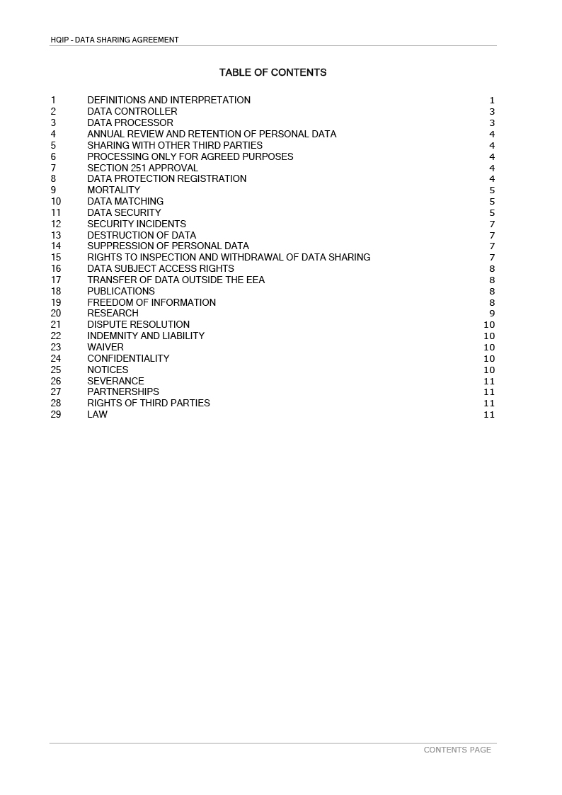

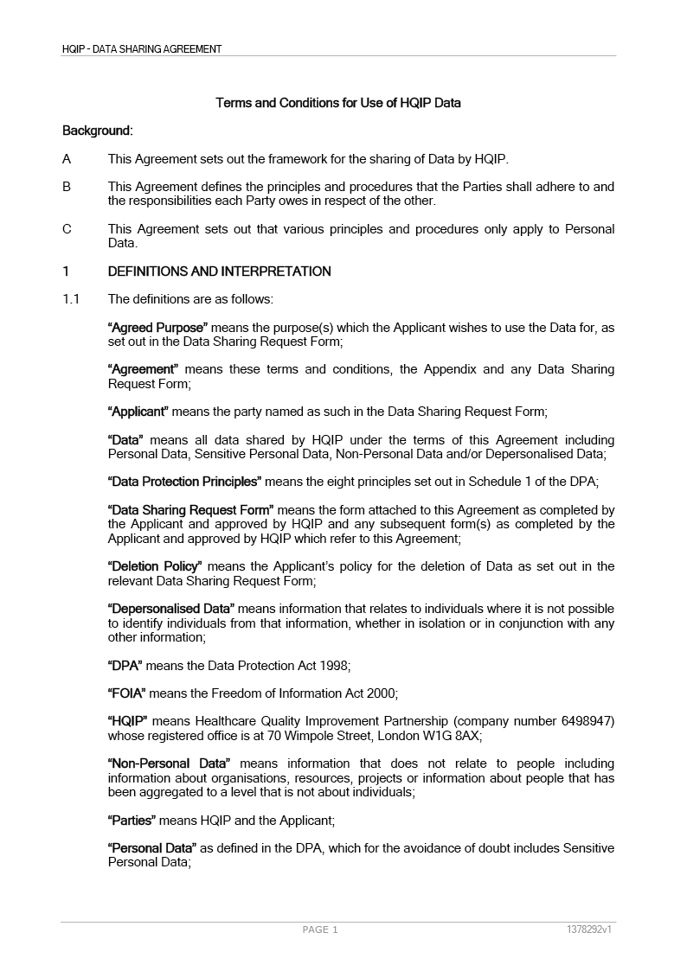

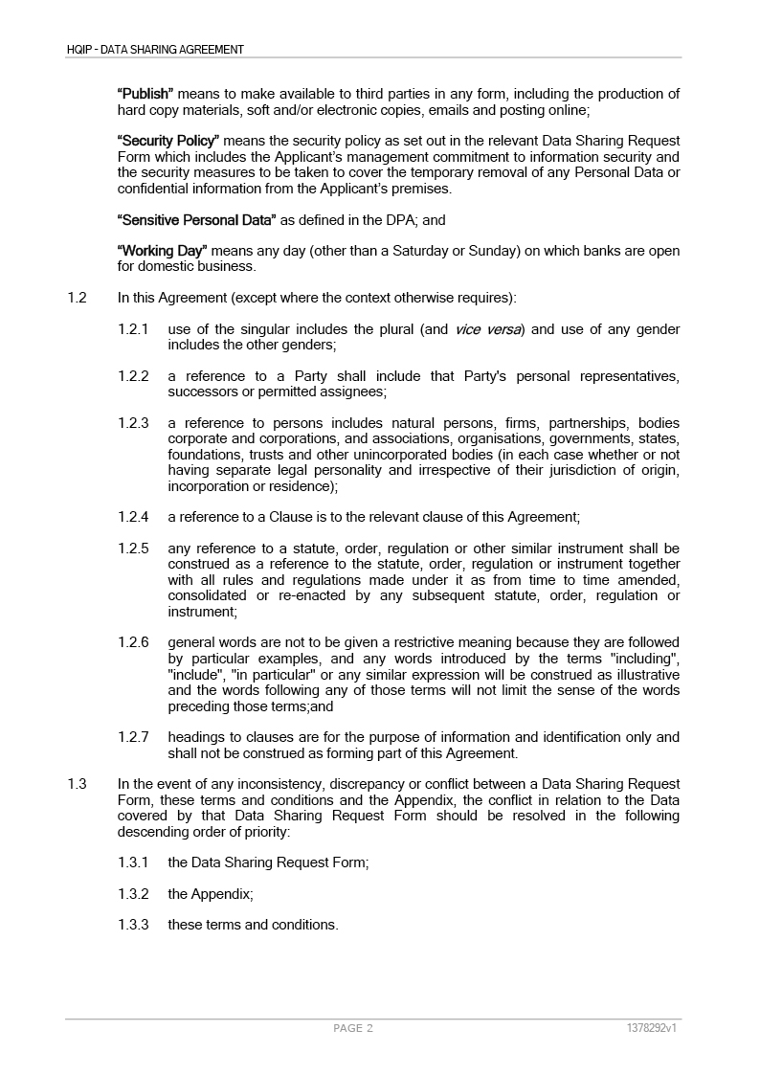

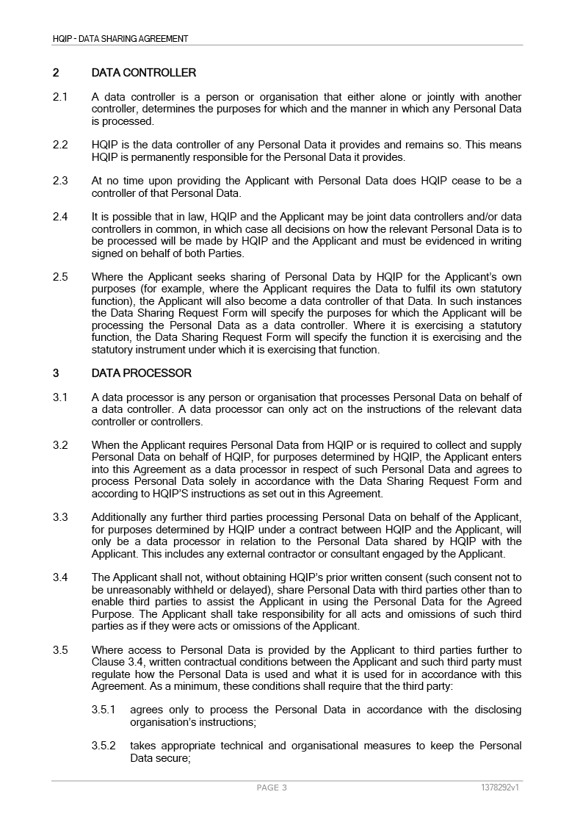

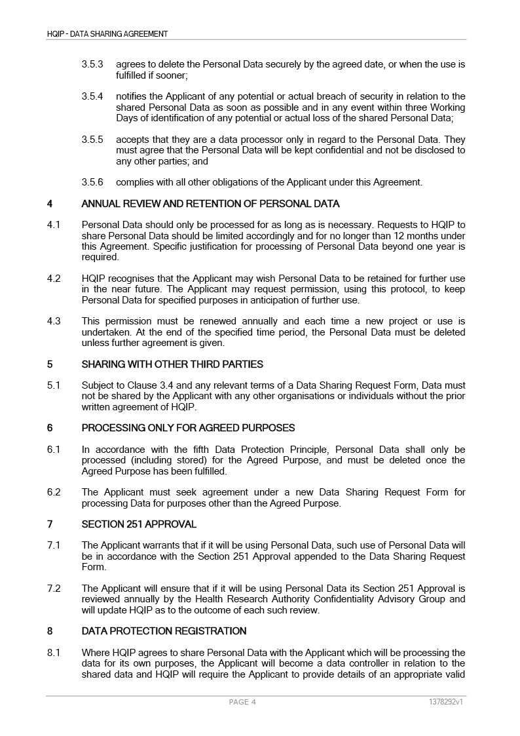

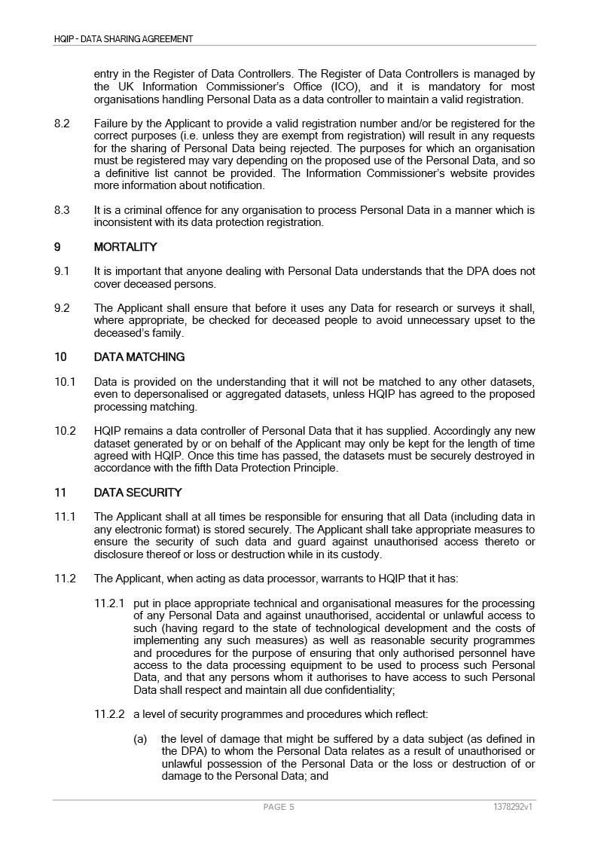

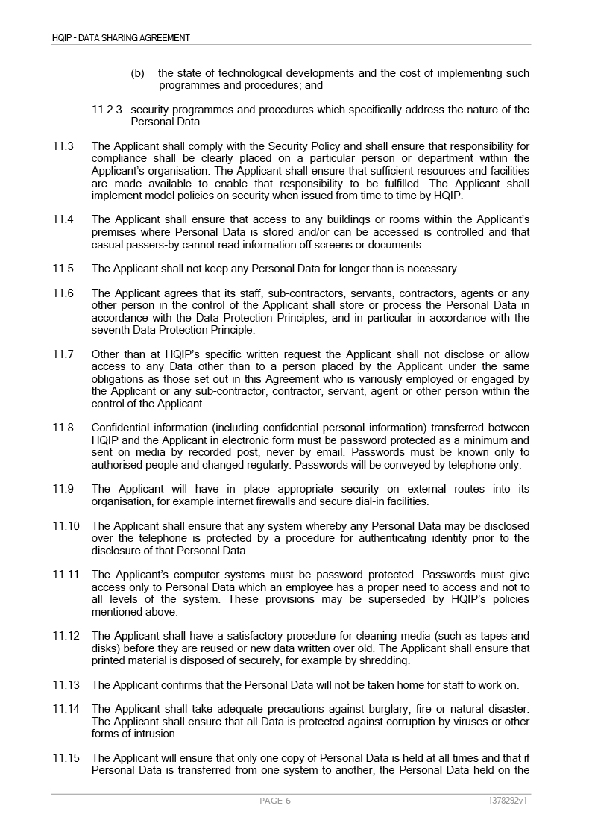

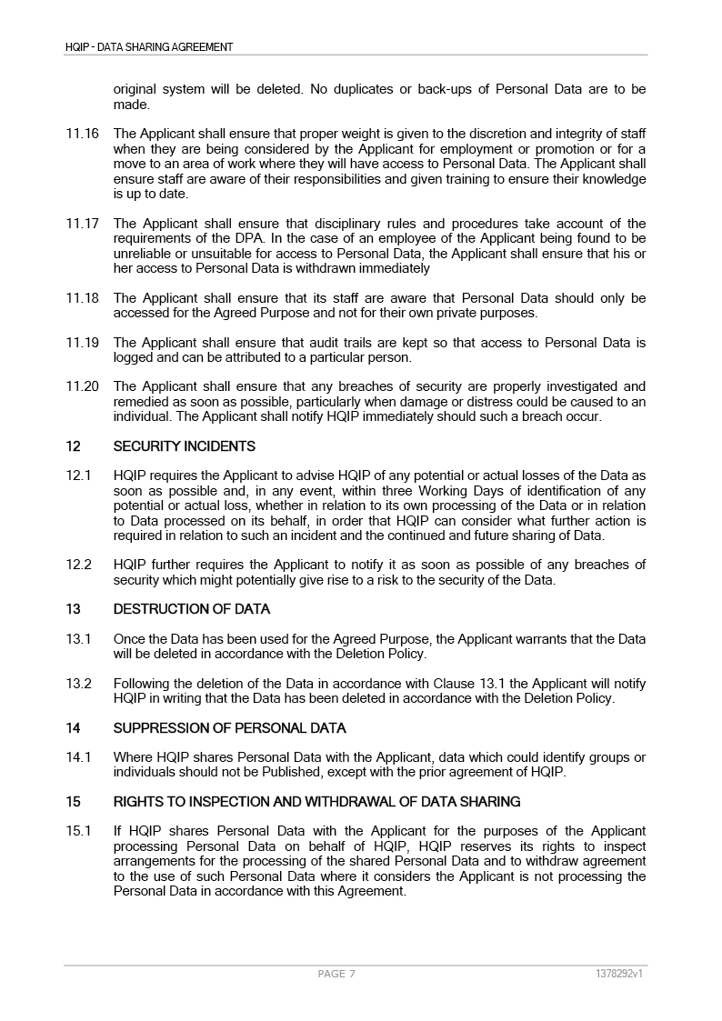

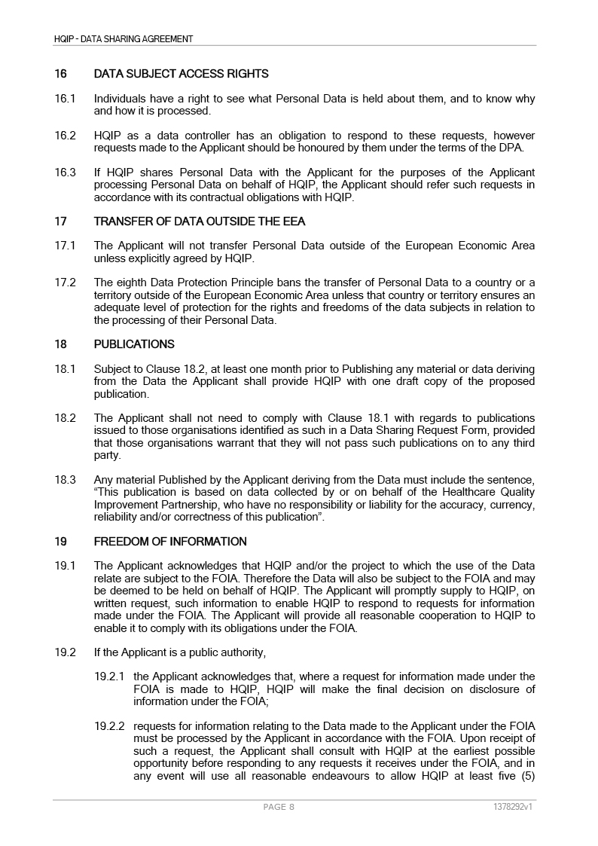

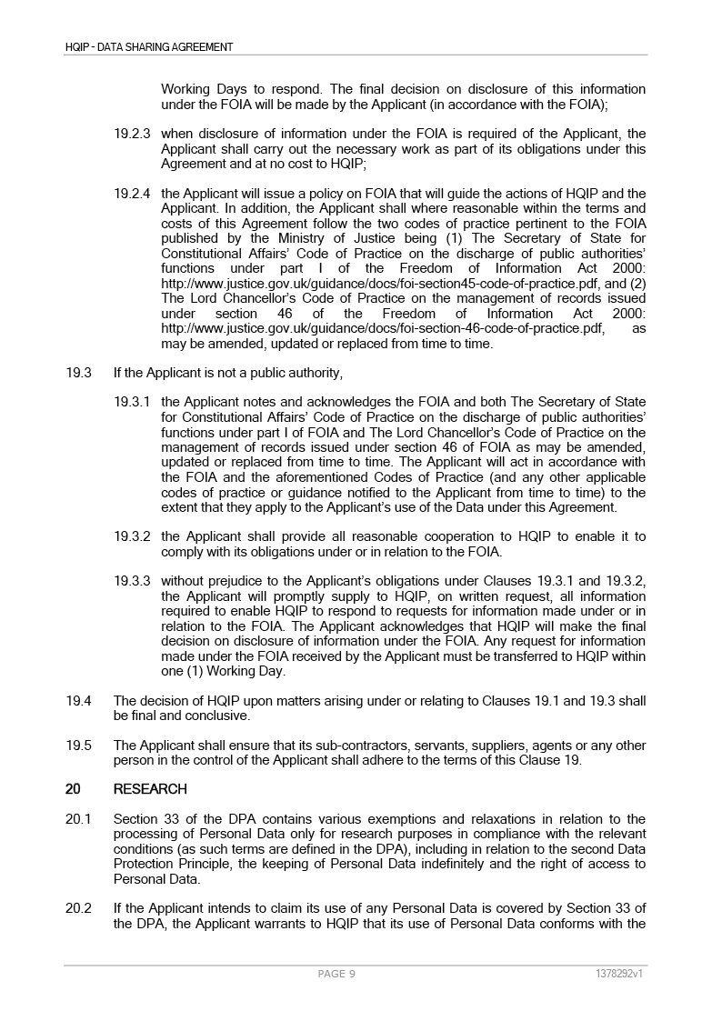

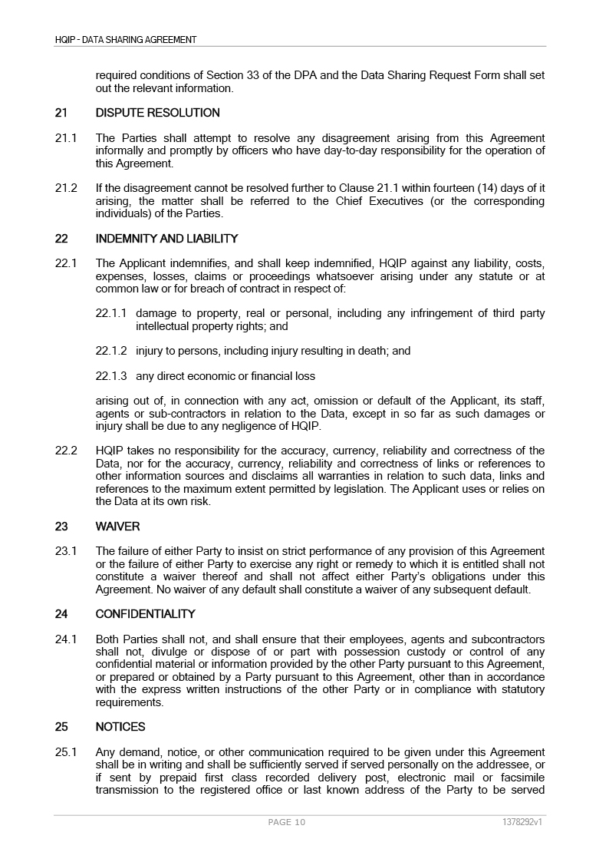

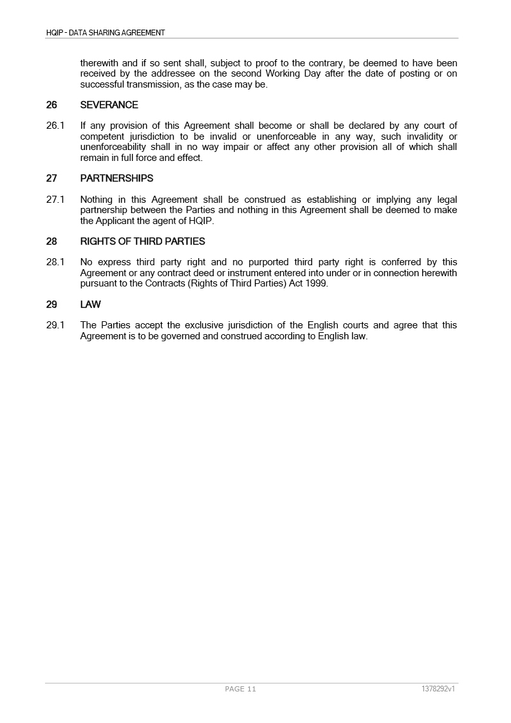

|  |  |  |  |
| --- | --- | --- | --- |
| **../Images/Screenshots/Screen%20Shot%202017-03-07%20at%2017.06.32.png** | **../Images/Screenshots/Screen%20Shot%202017-03-07%20at%2017.06.40.png** | | |
| ../Images/Screenshots/Screen%20Shot%202017-03-07%20at%2017.06.47.png | | | |
| ../Images/Screenshots/Screen%20Shot%202017-03-07%20at%2017.06.55.png | | ../Images/Screenshots/Screen%20Shot%202017-03-07%20at%2017.07.02.png | Click or tap here to enter text. |
| ../Images/Screenshots/Screen%20Shot%202017-03-07%20at%2017.07.05.png | Click or tap here to enter text. |
| ../Images/Screenshots/Screen%20Shot%202017-03-07%20at%2017.07.10.png |  |
| ../Images/Screenshots/Screen%20Shot%202017-03-07%20at%2017.07.24.png |  |
| **../Images/Screenshots/Screen%20Shot%202017-03-07%20at%2017.07.30.png** ../Images/Screenshots/Screen%20Shot%202017-03-07%20at%2017.07.35.png | | ../Images/Screenshots/Screen%20Shot%202017-03-07%20at%2017.07.02.png | Click or tap here to enter text. |
| ../Images/Screenshots/Screen%20Shot%202017-03-07%20at%2017.07.05.png | Click or tap here to enter text. |
| ../Images/Screenshots/Screen%20Shot%202017-03-07%20at%2017.07.10.png |  |
| ../Images/Screenshots/Screen%20Shot%202017-03-07%20at%2017.07.24.png |  |
| **../Images/Screenshots/Screen%20Shot%202017-03-07%20at%2017.08.00.png** ../Images/Screenshots/Screen%20Shot%202017-03-07%20at%2017.08.04.png | | ../Images/Screenshots/Screen%20Shot%202017-03-07%20at%2017.07.02.png | Click or tap here to enter text. |
| ../Images/Screenshots/Screen%20Shot%202017-03-07%20at%2017.07.05.png | Click or tap here to enter text. |
| ../Images/Screenshots/Screen%20Shot%202017-03-07%20at%2017.07.10.png |  |
| ../Images/Screenshots/Screen%20Shot%202017-03-07%20at%2017.07.24.png |  |
| **../Images/Screenshots/Screen%20Shot%202017-03-07%20at%2017.08.12.png** ../Images/Screenshots/Screen%20Shot%202017-03-07%20at%2017.08.16.png | | ../Images/Screenshots/Screen%20Shot%202017-03-07%20at%2017.07.02.png | Click or tap here to enter text. |
| ../Images/Screenshots/Screen%20Shot%202017-03-07%20at%2017.07.05.png | Click or tap here to enter text. |
| ../Images/Screenshots/Screen%20Shot%202017-03-07%20at%2017.07.10.png |  |
| ../Images/Screenshots/Screen%20Shot%202017-03-07%20at%2017.07.24.png |  |
| ../Images/Screenshots/Screen%20Shot%202017-03-07%20at%2017.08.23.png../Images/Screenshots/Screen%20Shot%202017-03-07%20at%2017.08.23.png | |  | |

Once completed please return this signed form to [**datasharing@hqip.org.uk**](mailto:datasharing@hqip.org.uk)

**../Images/Screenshots/Screen%20Shot%202017-03-07%20at%2017.08.55.png**

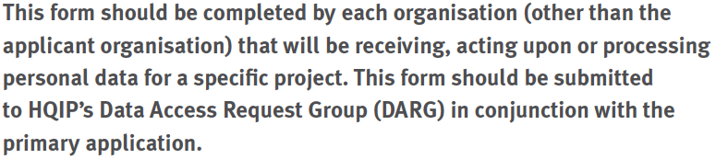

|  |  |
| --- | --- |
| **../Images/Screenshots/Screen%20Shot%202017-03-07%20at%2017.09.21.png** | |
| ../Images/Screenshots/Screen%20Shot%202017-03-07%20at%2017.09.29.png | Click or tap here to enter text. |
| ../Images/Screenshots/Screen%20Shot%202017-03-07%20at%2017.09.35.png | Click or tap here to enter text. |
| ../Images/Screenshots/Screen%20Shot%202017-03-07%20at%2017.09.42.png | Click or tap here to enter text. |
| ../Images/Screenshots/Screen%20Shot%202017-03-07%20at%2017.09.49.png | Click or tap here to enter text. |

|  |  |  |  |  |
| --- | --- | --- | --- | --- |
| **../Images/Screenshots/Screen%20Shot%202017-03-07%20at%2017.09.57.png** | | | | |
| ../Images/Screenshots/Screen%20Shot%202017-03-07%20at%2017.10.03.png | | | | |
| ../Images/Screenshots/Screen%20Shot%202017-03-07%20at%2017.10.13.png | Click or tap here to enter text. | | | |
| ../Images/Screenshots/Screen%20Shot%202017-03-07%20at%2017.10.19.png | Click or tap here to enter text. | | | |
| ../Images/Screenshots/Screen%20Shot%202017-03-07%20at%2017.10.24.png | Click or tap here to enter text. | | | |
| ../Images/Screenshots/Screen%20Shot%202017-03-07%20at%2017.10.32.png | Click or tap here to enter text. | | | |
| ../Images/Screenshots/Screen%20Shot%202017-03-07%20at%2017.10.37.png | Click or tap here to enter text. | | | |
| ../Images/Screenshots/Screen%20Shot%202017-03-07%20at%2017.10.44.png  ../Images/Screenshots/Screen%20Shot%202017-03-07%20at%2017.10.48.png |  | ../Images/Screenshots/Screen%20Shot%202017-03-07%20at%2017.10.53.png |  | ../Images/Screenshots/Screen%20Shot%202017-03-07%20at%2017.10.57.png |
| Click or tap here to enter text. | | | |

|  |  |  |  |  |  |
| --- | --- | --- | --- | --- | --- |
| **../Images/Screenshots/Screen%20Shot%202017-03-07%20at%2017.11.30.png** | | | | | |
| ../Images/Screenshots/Screen%20Shot%202017-03-07%20at%2017.11.36.png | | | | | |
|  | ../Images/Screenshots/Screen%20Shot%202017-03-07%20at%2017.11.44.png | | | | |
|  | ../Images/Screenshots/Screen%20Shot%202017-03-07%20at%2017.11.50.png | | | | |
|  | ../Images/Screenshots/Screen%20Shot%202017-03-07%20at%2017.11.56.png | | | | |
| ../Images/Screenshots/Screen%20Shot%202017-03-07%20at%2017.12.02.png | | | | | |
|  | ../Images/Screenshots/Screen%20Shot%202017-03-07%20at%2017.12.07.png |  | ../Images/Screenshots/Screen%20Shot%202017-03-07%20at%2017.12.12.png |  | ../Images/Screenshots/Screen%20Shot%202017-03-07%20at%2017.12.17.png |
|  | ../Images/Screenshots/Screen%20Shot%202017-03-07%20at%2017.12.24.png | | | | |
| Click or tap here to enter text. | | | | | |

|  |  |  |  |
| --- | --- | --- | --- |
| **../Images/Screenshots/Screen%20Shot%202017-03-07%20at%2017.12.32.png** | | | |
| ../Images/Screenshots/Screen%20Shot%202017-03-07%20at%2017.12.41.png | | | |
|  | ../Images/Screenshots/Screen%20Shot%202017-03-07%20at%2017.12.47.png |  | ../Images/Screenshots/Screen%20Shot%202017-03-07%20at%2017.12.53.png |
| Click or tap here to enter text. | | | |

|  |  |  |
| --- | --- | --- |
| **../Images/Screenshots/Screen%20Shot%202017-03-07%20at%2017.13.01.png** | | |
| ../Images/Screenshots/Screen%20Shot%202017-03-07%20at%2017.13.06.png | Click or tap here to enter text. | |
| ../Images/Screenshots/Screen%20Shot%202017-03-07%20at%2017.13.15.png | Click or tap here to enter text. | |
| ../Images/Screenshots/Screen%20Shot%202017-03-07%20at%2017.13.24.png | Click or tap here to enter text. | |
| ../Images/Screenshots/Screen%20Shot%202017-03-07%20at%2017.13.30.png |  | ../Images/Screenshots/Screen%20Shot%202017-03-07%20at%2017.13.37.png |

|  |  |  |  |
| --- | --- | --- | --- |
| **../Images/Screenshots/Screen%20Shot%202017-03-07%20at%2017.13.59.png** | | | |
| ../Images/Screenshots/Screen%20Shot%202017-03-07%20at%2017.14.04.png | | | |
|  | ../Images/Screenshots/Screen%20Shot%202017-03-07%20at%2017.14.11.png |  | ../Images/Screenshots/Screen%20Shot%202017-03-07%20at%2017.14.16.png |
| Click or tap here to enter text. | | | |

|  |  |
| --- | --- |
| **../Images/Screenshots/Screen%20Shot%202017-03-07%20at%2017.14.24.png** | |
| ../Images/Screenshots/Screen%20Shot%202017-03-07%20at%2017.14.30.png | |
|  | ../Images/Screenshots/Screen%20Shot%202017-03-07%20at%2017.14.39.png |

|  |  |
| --- | --- |
| **../Images/Screenshots/Screen%20Shot%202017-03-07%20at%2017.14.43.png** | |
| ../Images/Screenshots/Screen%20Shot%202017-03-07%20at%2017.14.58.png | |
|  | ../Images/Screenshots/Screen%20Shot%202017-03-07%20at%2017.15.04.png |

|  |  |  |
| --- | --- | --- |
| **../Images/Screenshots/Screen%20Shot%202017-03-07%20at%2017.15.08.png** | | |
| ../Images/Screenshots/Screen%20Shot%202017-03-07%20at%2017.15.14.png | | |
| ../Images/Screenshots/Screen%20Shot%202017-03-07%20at%2017.15.24.png | ../Images/Screenshots/Screen%20Shot%202017-03-07%20at%2017.07.02.png | Click or tap here to enter text. |
| ../Images/Screenshots/Screen%20Shot%202017-03-07%20at%2017.07.05.png | Click or tap here to enter text. |
| ../Images/Screenshots/Screen%20Shot%202017-03-07%20at%2017.07.10.png |  |
| ../Images/Screenshots/Screen%20Shot%202017-03-07%20at%2017.07.24.png | Click or tap here to enter text. |